Recommender Systems

A recommender system is a system which predicts ratings or “preference” a user might give to a specific item. These predictions will then be ranked and returned back to the user. They are primarily used in commercial applications. They're used by various large name companies like Google, Instagram, Spotify, Amazon, Reddit, Netflix etc.

The recommender engines are a domain in themselves that have many types that can be classified under both supervised as well as unsupervised learning.

Recommender systems are beneficial to both service providers and users. They reduce transaction costs of finding and selecting items in an online shopping environment. Recommendation engines discovers data patterns in the data set by learning consumers choices and produces the outcomes that co-relates to their needs and interests.

In Real time examples are like Amazon, they have been using a recommendation engine for suggesting the goods or products that customers might also like. Netflix provide their members with personalized suggestions to reduce the amount of time and frustration to find something great content to watch.

Recommender systems are an integral part of the Media and Entertainment industry. There are six major recommender systems that work primarily in the Media and Entertainment industry----

1. Collaborative Recommender system

2. Content-based recommender system 3. Demographic-based recommender system

Collaborative Recommender system

4. Utility-based recommender system 5. Knowledge-based recommender system 6. Hybrid recommender system

Collaborative recommender systems aggregate ratings or recommendations of objects, recognize commonalities between the users on the basis of their ratings, and generate new recommendations based on inter-user comparisons.

Content-based recommender system

In this system, the objects are mainly defined by their associated features. A content-based recommender learns a profile of the new user’s interests based on the features present, in objects the user has rated. It’s basically a keyword-specific recommender system where keywords are used to describe the items. For example: The content-based system might consider the age, sex, occupation, and other personal user factors when making the predictions. It’s much easier to predict that the person wouldn’t like the video if we knew it was about skateboarding, but the user’s age is 87!

Demographic-based recommender system

In a Demographic-based recommender system, the algorithms first need proper market research in the specified region accompanied by a short survey to gather data for categorization. Demographic techniques form “people-to-people” correlations like collaborative ones but use different data. The benefit of a demographic approach is that it does not require a history of user ratings like that in collaborative and content-based recommender systems.

Utility-based recommender system

Utility-based recommender system makes suggestions based on the computation of the utility of each object for the user. In a utility-based system, every industry will have a different technique for arriving at a user-specific utility function and applying it to the objects under consideration. The main advantage of using a utility-based recommender system is that it can factor non-product attributes, such as vendor reliability and product availability, into the utility computation.

Knowledge-based recommender system

Knowledge based recommendation system works on functional knowledge: they have knowledge about how a particular item meets a particular user need, and can therefore reason about the relationship between a need and a possible recommendation.

Hybrid recommender system

Combining any of the two systems in a manner that suits a particular industry is known as Hybrid Recommender system. Benefits of the Recommendation system-

• Personalized content

• Help websites to improve user engagement • Benefits users in finding items of their interest

• Identity products that are most relevant to users • Help item providers in delivering their items to the right user

Page | 1

On the Internet, where the number of choices is overwhelming, there is a need to filter, prioritize and efficiently deliver relevant information in order to alleviate the problem of information overload, which has created a potential problem for many Internet users. Recommender systems solve this problem by searching through the large volume of dynamically generated information to provide users with personalized content and services.

Information retrieval systems, such as Google, Altavista and others have partially solved this problem but prioritization and personalization of information were absent. This has increased the demand for recommender systems more than ever before.

Recommender system has the ability to predict whether a particular user would prefer an item or not based on the user’s profile. Recommendation systems have also proved to improve decision making process and quality. In e-commerce setting, recommender systems enhance revenues, for the fact that they are effective means of selling more products.

Fig.: Recommendation Filtering Techniques 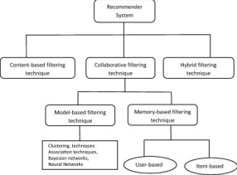 Fig.: Collaborative Filtering Process 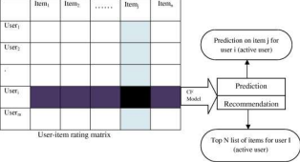

Assume that, for simpler video recommendation, in such that case, based on videos a user has watched, we can simply suggest same authors videos or same publications videos---- Popularity Based, Classification Based & Collaborative Filtering

Popularity Based:

Easiest way to build a recommendation system is popularity based, simply over all the products that are popular, so how to identify popular products, which could be identified by which are all the products that are bought most. Example, in shopping store we can suggest popular dresses by purchase count.

Merits

• From day 1 of the business also it can recommend products on various different filters

• There is no need for the user's historical data

Demerits

• Not personalized

• Recommend the same sort of products/movies which are solely based upon popularity to every other user

Page | 2

Example

• Google News: News filtered by trending and most popular news

• YouTube: Trending videos

Classification Based

Second way to build a recommendation system is classification model, in that use feature of both users as well as products in order to predict whether this product liked or not by the user.

When new users come, our classifier will give a binary value of that product liked by this user or not, in such a way that we can recommend a product to the user.

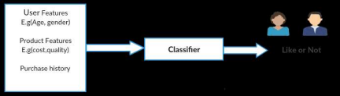

In above example using user features like Age, gender and product features like cost, quality and product history, based on this input our classifier will give a binary value user may like or not, based on that Boolean we could recommend product to a customer.

Limitations:

• It is a rigorous task to collect a high volume of information about different users and also products • Also, if the collection is done then also it can be difficult to classify

• Flexibility issue

Collaborative Filtering:

Collaborative filtering models which are based on assumption that people like things similar to other things they like, and things that are liked by other people with similar taste.

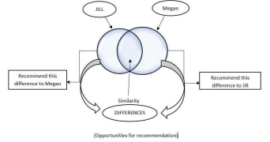

Limitations

• Enough users required to find a match. To overcome such cold start problems, often hybrid approaches are made use of between CF and Content-based matching.

• Even if there are many users and many items that are to be recommended often, problems can arise of user and rating matrix to be sparse and will become challenging to find out about the users who have rated the same item. • The problem in recommending items to the user due to sparsity problems.

Page | 3

Top recommendation systems on the internet

Nowadays, all major digital service providers and ecommerce enterprises rely on recommendation systems to deliver a customized user experience and enhance sales performance or advertising revenues:

A

mazon leverages a recommendation algorithm to recommend products or search results, combining in-site suggestions based on several strategies (recommended for you, bought together, recently viewed, etc.) with off-site recommendations via email. The ecommerce leader deployed its collaborative filtering-based recommender engine between 2011 and 2012, recording an outstanding 29% sales increase in the second fiscal quarter of 2012.

Y

ouTube implemented a recommendation system to prioritize certain videos, suggest channel subscriptions, and provide relevant news. The engine takes into account a variety of parameters, defined as "signals" to better frame user interests, including clicks, likes and dislikes, watch time, and shares.

F

acebook uses a recommendation engine based on deep learning and neural networks (known as DLRM or Deep-learning Recommendation Model) for friend suggestions and News Feed sorting, but also to recommend groups, pages you may be interested in, or products on its Marketplace.

N

etflix relies on a recommendation system to provide movie recommendations. Its algorithms consider variables such as user features (including browsing history and ratings issued), movie type and popularity, seasonal trends, and item item similarity with previous content to sort the groups of movies displayed in horizontal rows on its home page.

L

inkedIn deployed a recommendation system to suggest job ads, connections, and courses. One of its core applications is LinkedIn Recruiter, a powerful HR tool capable of compiling lists of suitable candidates for an open position and ranking them depending on their skills, experience, and likelihood of a response.

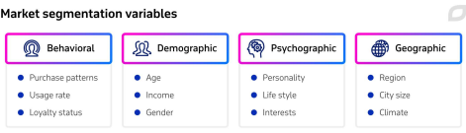

ML-based recommendation system benefits

Following the transition from brick-and-mortar sales to ecommerce, coupled with the spread of online platforms ensuring remote access to digital content, retail corporations and service providers have relied on machine learning-powered recommendation systems and other big data ecommerce solutions to achieve five essential goals:

Better user experience:

Recommendation systems help replicate the in-store customer care and personalized shopping experience, offered by a real salesperson who provides an undecided purchaser with expert guidance, in a virtual environment.

Focus on the right product:

Recommender systems mitigate the so-called information overload as they direct customers towards the product (be it physical or digital) they really want, hidden amid an overwhelming offer of merchandise and content.

Sales drive:

Personalizing the shopping experience and highlighting relevant products result in a higher number of items per order, superior average order value, and enhanced customer lifetime value.

Page | 4

Data-driven decision-making:

Recommendation systems gather customer and sales data and compile detailed reports, providing managers with valuable insights to enhance their decision-making in terms of marketing, logistics, and pricing strategies.

Revenue growth:

As a consequence of the previous points, recommendation systems can act as powerful revenue boosters. In this regard, McKinsey's 2019 The Future of Personalization article highlighted that product recommendation solutions may help improve marketing-spend efficiency by 10-30% and increase revenues by 5-15%.

Page | 5